Kiwi or Stoat?



In this project, you will train a computer to recognise photos of kiwi birds and stoats.

Photos for this project were collected at different sites within New Zealand, by the Department of Conservation of New Zealand.

Following the steps below you will use Scratch to create an app that recognises photos of kiwi birds and stoats.

For a broader understanding about New Zealand biodiversity and the use of remote cameras, you can take the [online course offered by wildlife.ai](https://www.wildlife.ai/courses/identifying-photographs-of-animals-kiwi-or-stoat/) associated with this project.

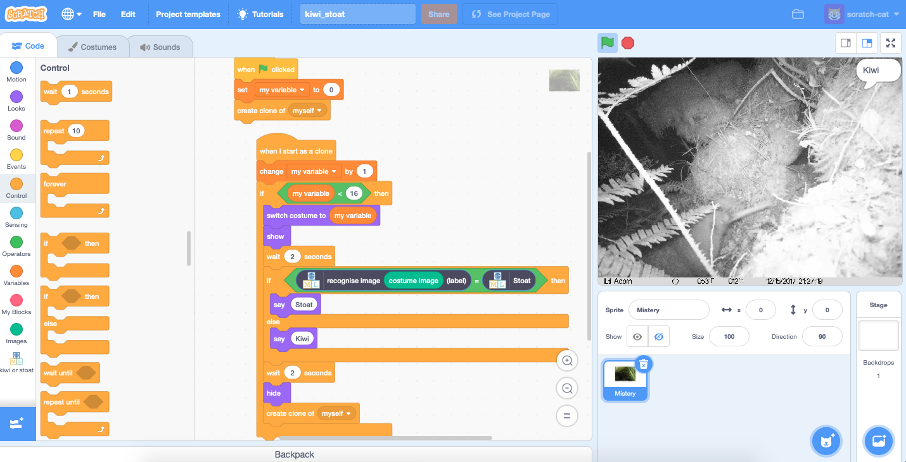

This project worksheet is licensed under a Creative Commons Attribution Non-Commercial Share-Alike License



http://creativecommons.org/licenses/by-nc-sa/4.0/

1. Go to <https://machinelearningforkids.co.uk/> in a web browser
2. Click on “**Get started**”
3. Click on “**Log In**” and type in your username and password  
   *If you don’t have a username, ask your teacher or group leader to create one for you.  
   If you can’t remember your username or password, ask your teacher or group leader to reset it for you.*
4. Click on “**Projects**” on the top menu bar
5. Click the **“+ Add a new project**” button.
6. Name your project “Kiwi or stoat” and set it to learn how to recognise “**images**”.   
   Click the “**Create**” button  
   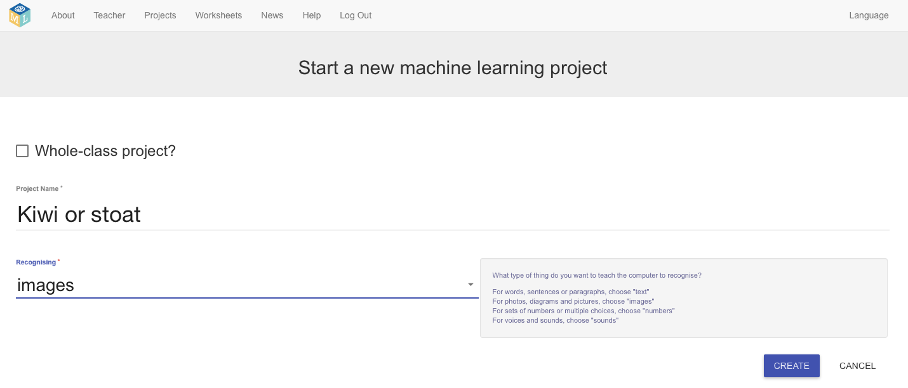
7. You should now see “**Kiwi or stoat**” in the list of your projects.   
   Click on it.
8. Click the “**Train**” button to start collecting examples.  
   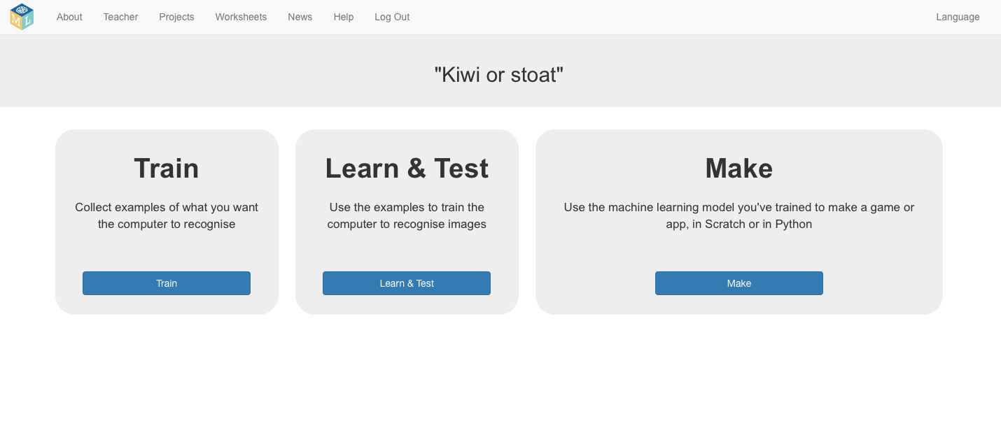

1. Click on **“+ Add new label**” and call it “kiwi”.   
   Do that again, and create a second bucket called “stoat”.  
   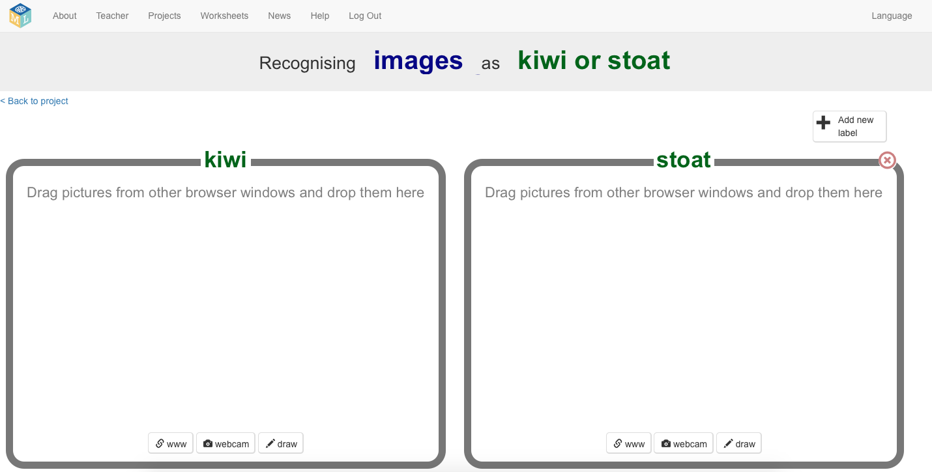

1. Open another web browser window.
2. Go to   
   <https://wildlife.ai/portfolio-items/kiwi-and-stoat-photos/>
3. Arrange the web browser windows so they are side by side.  
   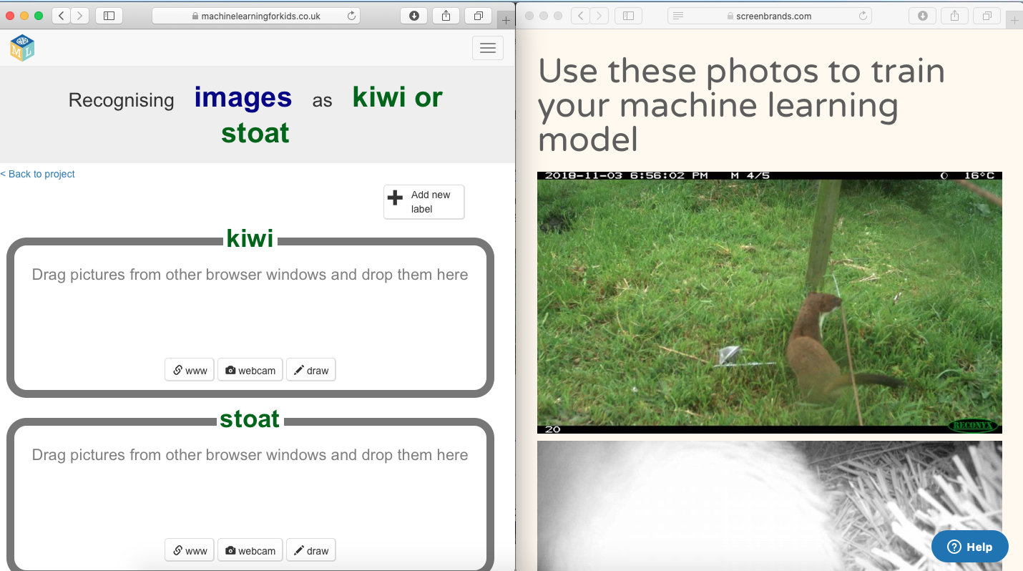
4. Start dragging examples of kiwi and stoat photos into the buckets.   
   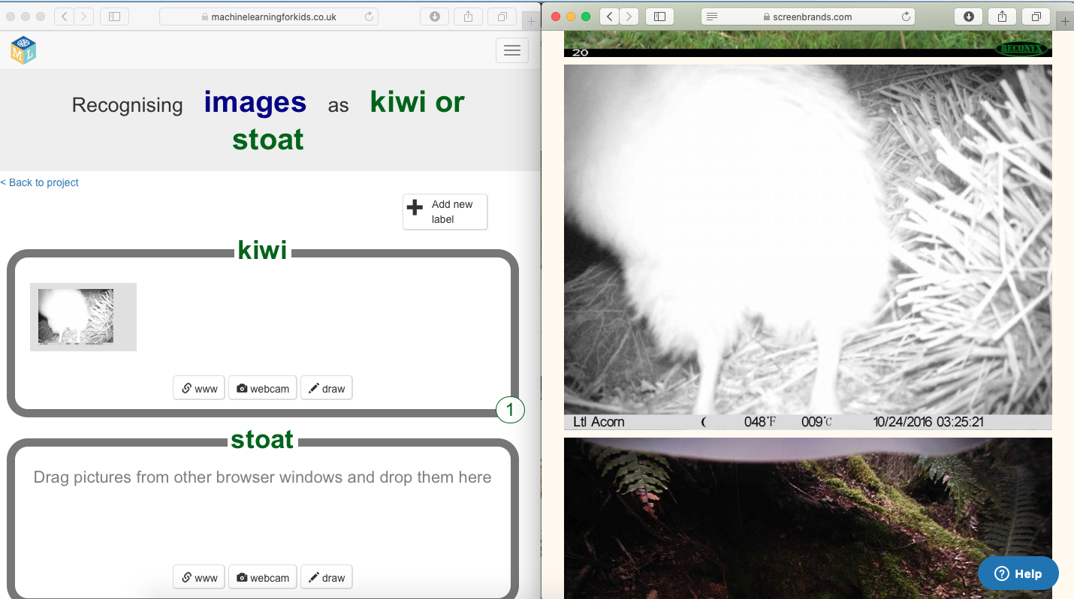
5. Repeat until you’ve got at least 10 examples of kiwi and stoat photos.  
   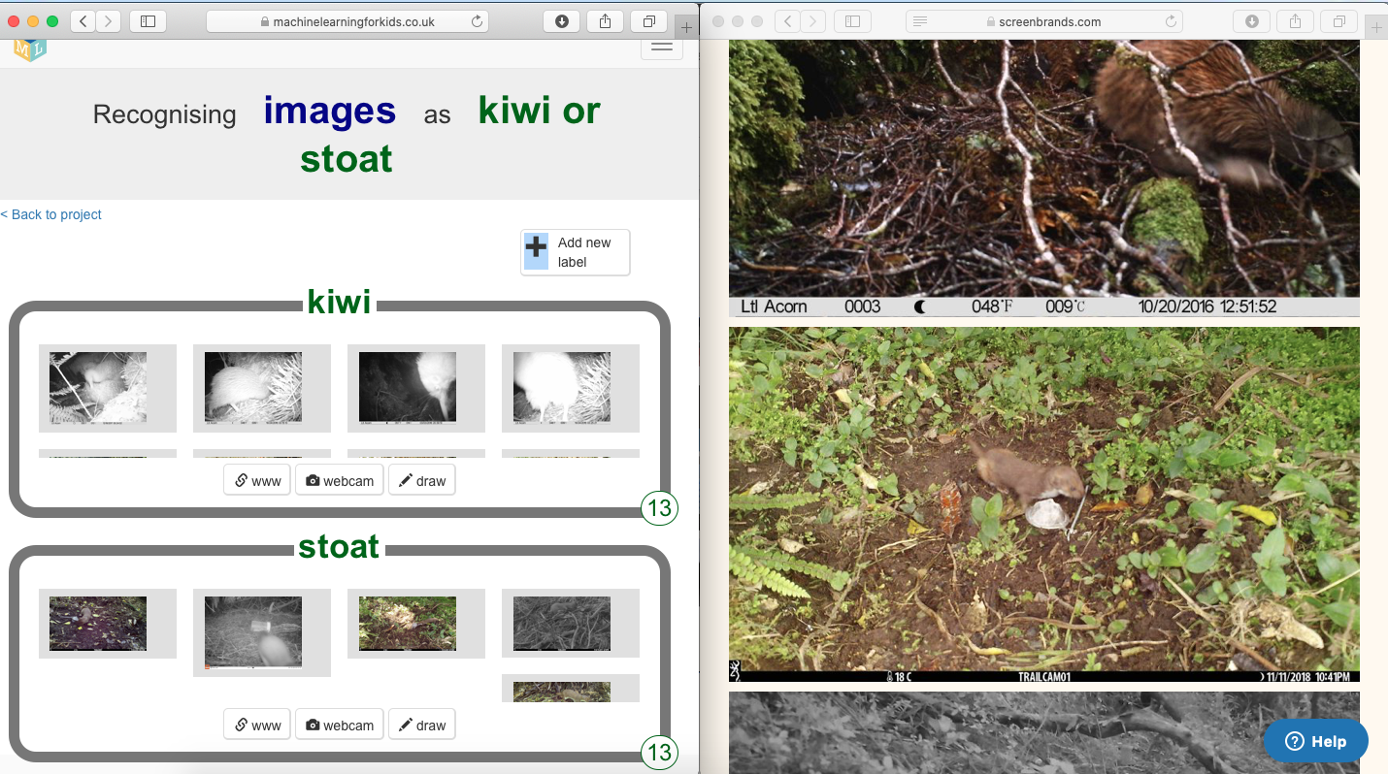
6. Click the “**< Back to project**” link.
7. Click the “**Learn & Test**” button
8. Click the “**Train new machine learning model**” button  
   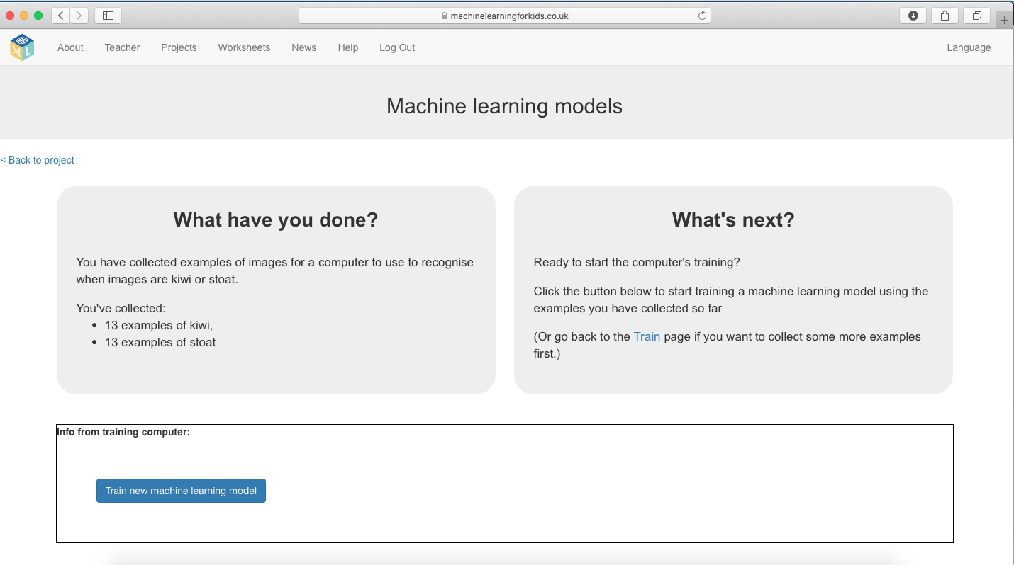  
   
9. Wait for the training to complete. This might take a few minutes.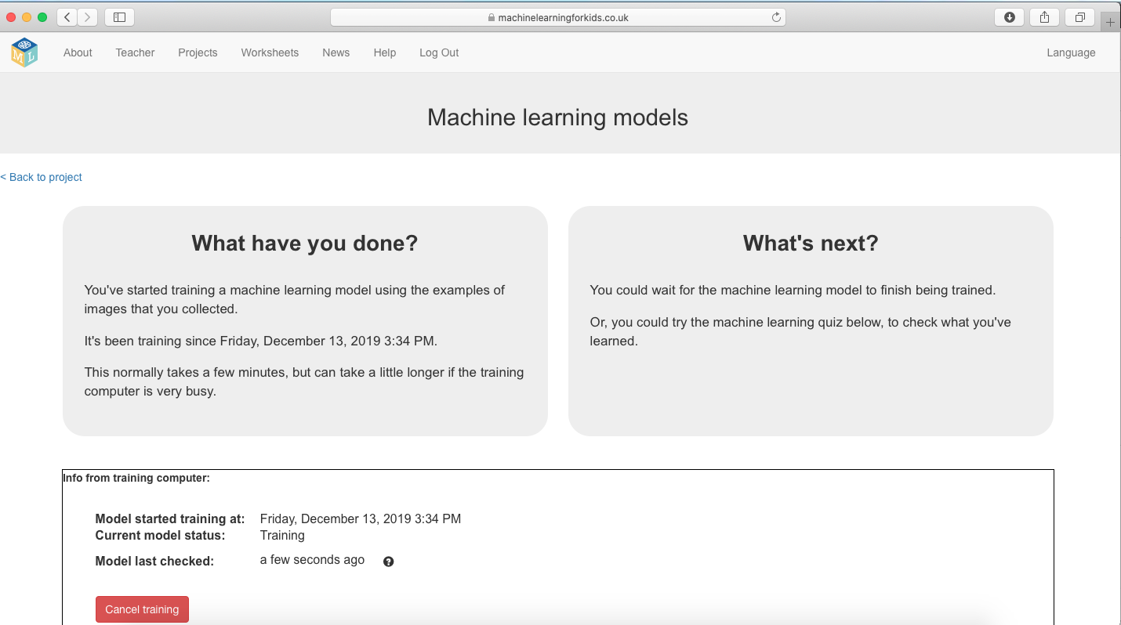

**What have you done so far?**

You’ve started to train a computer to recognise pictures of kiwi and stoats. Instead of trying to write rules to be able to do this, you are doing it by collecting examples. These examples are being used to train a machine learning “model”.

This is called “supervised learning” because of the way you are supervising the computer’s training.

The computer will learn from patterns in the example photos you’ve chosen, such as the shapes and the use of colour. These will be used to be able to recognise new images.

1. Click the **“< Back to project**” link
2. Click the “**Make**” button, and then the “**Scratch 3**” button.
3. Click the “**Open in Scratch 3**” button
4. Load the **Kiwi or stoat** template   
   *Click on* ***Project templates*** *and then click on* ***Kiwi or stoat***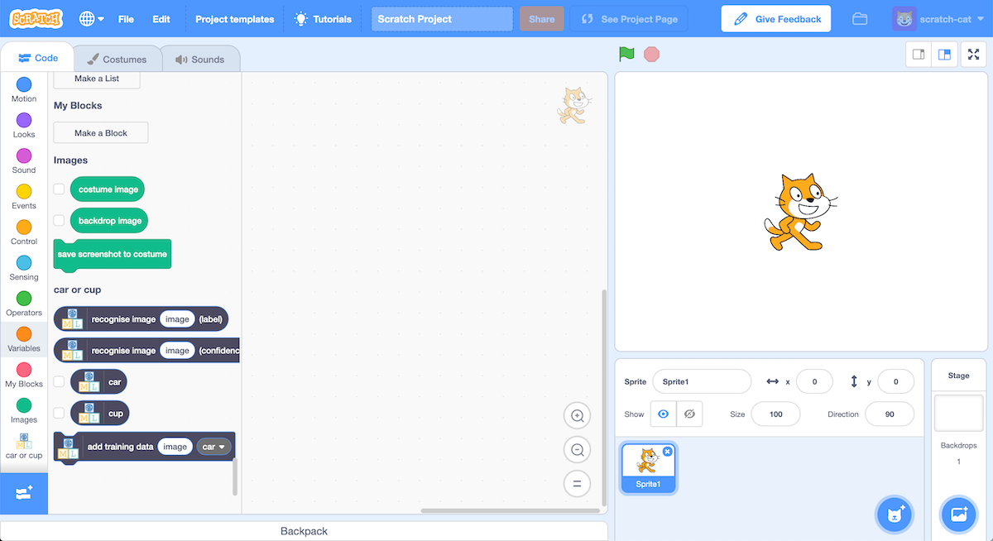
5. Click the **green flag** to give it a try.  
   *The project has 15 photos of stoats or kiwi that the computer has never seen before.   
   Next you will modify the project to use the training you’ve given the computer, so that it can identify the animals in the 15 photos.* ***A screenshot of a cell phone

   Description automatically generated***

**Tips**

**More examples!**

The more examples you give it, the better the computer should get at recognising whether a photo is a kiwi or stoat.

**Try and be even**

Try and come up with roughly the same number of examples for kiwi and stoats.

If you have a lot of examples for one type, and not the other, the computer might learn that type is more likely, so you’ll affect the way that it learns to recognise photos.

**Mix things up with your examples**

Try to come up with lots of different types of examples.

For example, make sure that you include some examples with different backgrounds.   
  
If every photo of a stoat you use for training has a bait, and every photo of kiwi doesn’t have it, you might end up training the computer to recognise baits instead.

1. Click on the “Mystery” sprite, then the “**Code**” tab, and **change the script** to use your machine learning model.  
   *Start from the script that is already there and change it to look like this.*   
   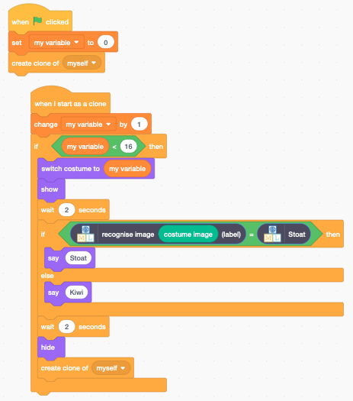
2. Click the **full screen** icon, and then click the **green flag**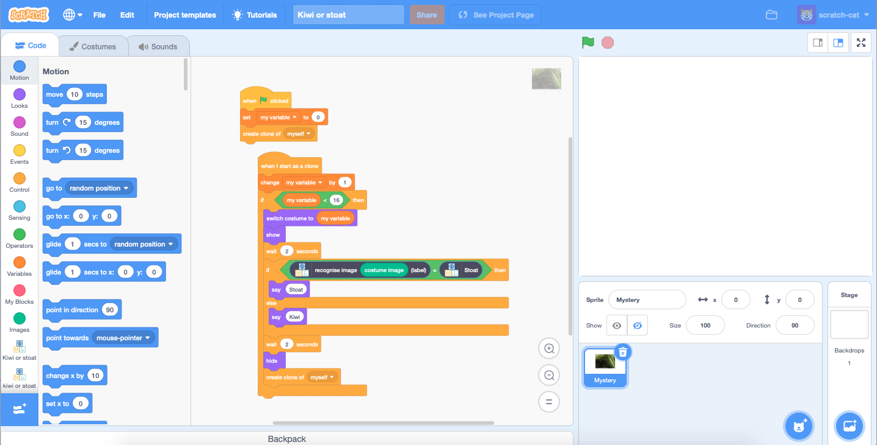

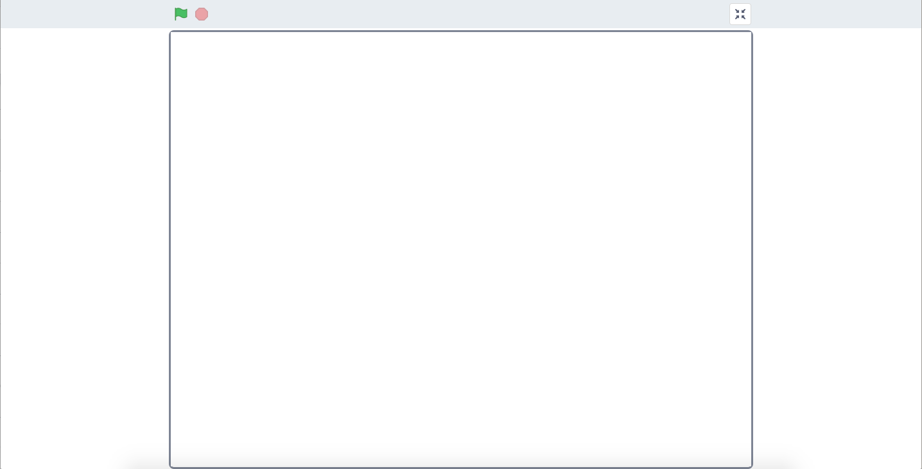  


1. Watch your script use your model to identify the photos.   
   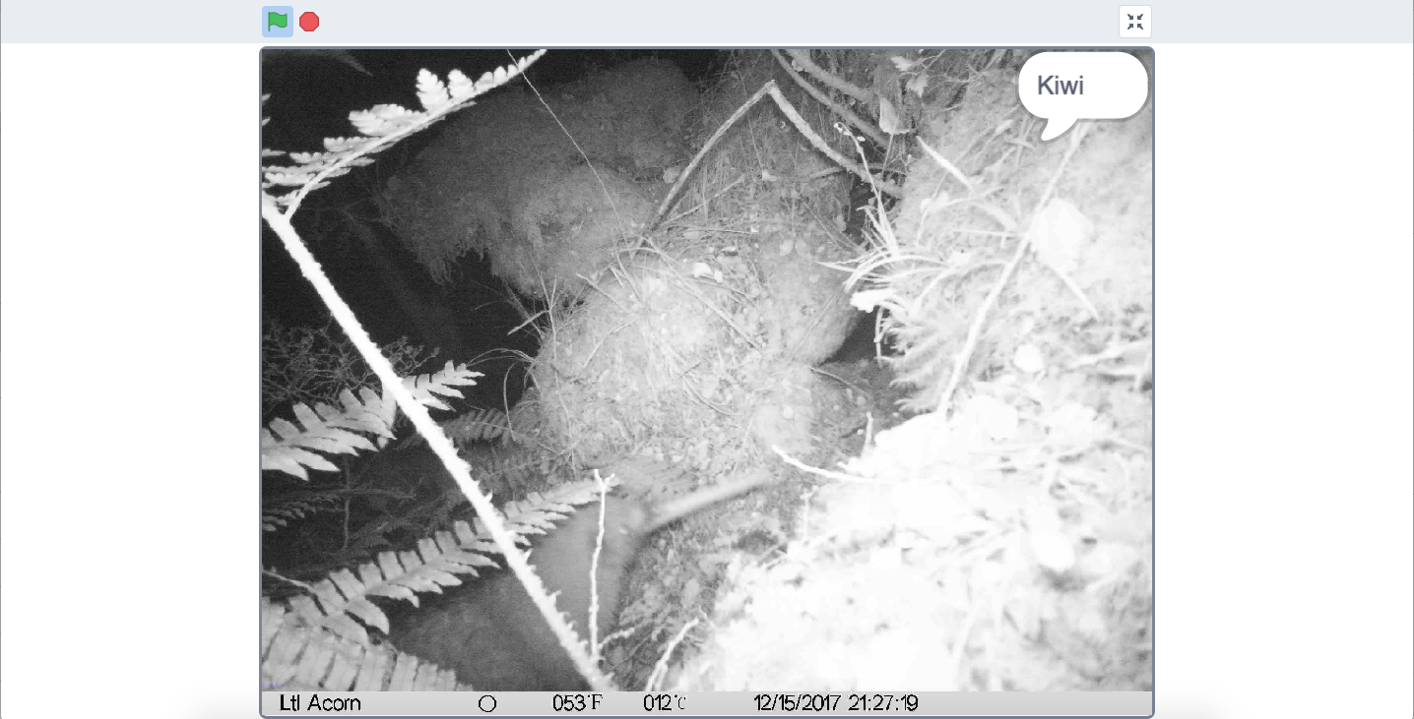
2. If your trained system makes mistakes, you’ll need to go back to step 13, and collect more examples.   
   *Make sure you repeat step 18 to train a new model.*

**What have you done?**

You’ve used machine learning to build an automatic photo sorter.

Training the computer to be able to recognise photos of animals for itself is much quicker than trying to classify the photos manually.

The more examples you give it, the better it should get at recognising photos correctly.

**Ideas and Extensions**

Now that you’ve finished, why not give one of these ideas a try?

Or come up with one of your own?

**Add a third type of photo**

Instead of just recognising stoats and kiwi, what will happen if you add a third animal as well?

**Recognise images of different things**

Try the “Car or Cup” project to train the computer to recognise objects instead of animals.